NATIONAL INSTITUTE OF TECHNOLOGY, WARANGAL



LICA Project

LED Chaser Circuit

Submitted by:

**TANUMON ROY (174259)**

**ARYAN YADAV (174203)**

Submitted to:

**Dr. J Ravi Kumar**

Associate Professor

NIT Warangal

**Department of Electronics and Communication Engineering**

**National Institute of Technology**

**Warangal – 506 004, Telangana, India**



**CERTIFICATE**

This is to certify that the project work entitled **“LICA Project : LED Chaser Circuit”**, which is being submitted by Mr. **TANUMON ROY (Roll No. 174259)** and Mr. **ARYAN YADAV (Roll No. 174203)**, is a bonafide work submitted to National Institute of Technology Warangal in partial fulfillment of the requirement for the award of the degree of

**Bachelor of Technology (B. Tech) in Electronics and Communication Engineering.**

To the best of our knowledge, the work incorporated in this project has not been submitted elsewhere for the award of any degree.

**Dr. J. Ravi Kumar**

Associate Professor

Department of ECE

National Institute of Technology

Warangal – 506 004

# index:

|  |  |
| --- | --- |
| Topic | Page No. |
| AIM | 4 |
| INTRODUCTION | 4 |
| CIRCUIT | 5 |
| WORKING PRINCIPLE | 6 |
| LIST OF COMPONENTS | 9 |
| RESULT | 10 |
|  |  |

# Aim:

To design a LED chaser circuit using 555-timer IC and CD4017 (Decade counter IC)

# Introduction:

The so-called chaser or sequencer is one of the most popular types of LED-driving circuit and is widely used in advertising displays and in running-light ‘rope’ displays in small discos, etc.

It consists — in essence — of a clocked IC or other electronic unit that drives an array of LEDs in such a way that individual LEDs (or small groups of LEDs) turn on and off in a predetermined and repeating sequence, thus producing a visually attractive display in which one or more ripples of light seem to repeatedly run through a chain or around a ring of LEDs.

The 4017B CMOS IC is probably the best known and most widely used LED-driving IC used in chaser/sequencer applications.

When we power the circuit, LEDs start glowing one by one for a defined time period. Means first LED Q1 glows and then Q2 glows and Q1 turned OFF and then Q3 glows and Q2 turned OFF and so on. When we change resistance of variable resistor then speed of LEDs increase. Because frequency of 555 timer increases and this increases frequency signal is directly connected to counter’s trigger pin. So that counter changes its state faster.

# Circuit:

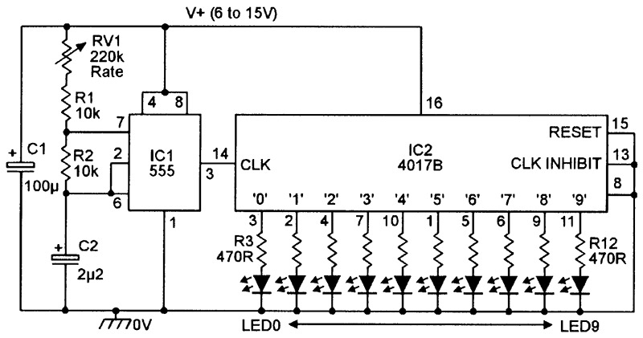

# Working Principle:

555 Timer IC :

The main part of this LED chaser circuit diagram is **555 timer IC** which generates some variable frequency. [555 timer IC](http://circuitdigest.com/article/555-timer-ic) is a general purpose IC which can be configured in some different modes like Astable, Monostable and Bistable. Here in this project we configured 555 timer as an Astable multivibrator in which both the stages of signal are unstable. Some time we call frequency generator also. Here we use output signal of this Astable multivibrator to trigger IC CD 4017 counter to change its state to perform desired task.

Here we have connected 555 timer IC in Astable mode for generating a trigger pulse of some time period. A variable resistor is connected for changing the cycle frequency of 555 timer’s output. A CD4017 counter IC is also connected with this circuit for lighting LEDs. 10 red LED’s are connected to Q0-Q9 pin (pin 3) through 150 ohm resistor. MR pin (pin 15), enable or clock inhibit pin (pin 13) is directly connected with ground and Clock pin of counter directly connected with output pin of 555 Timer.

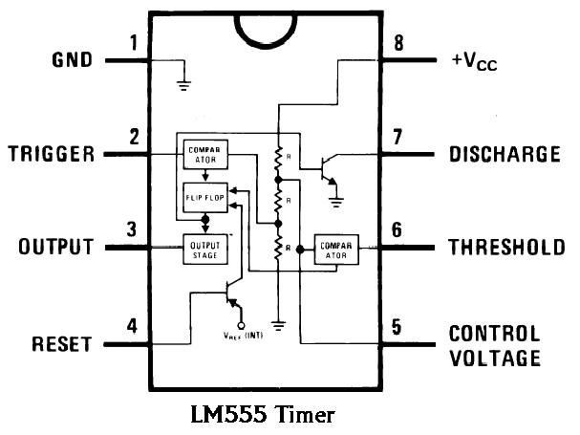

555 timer frequency formula:

We know that

Vc(t) = Vf + (Vi – Vf)exp(-t/RC)

Here, Vf = Vcc ; Vi = Vcc/3 ; Vc(T1) = 2Vcc/3

While charging, the capacitor charges through both resistors R1 and R2.

While discharging, the capacitor discharges only through R2.

So, solving the above equations we get

The charge time (output HIGH) is given by :

T1 = 0.693 (R1 +R2) C

The discharge time (output LOW) by :

T2 = 0.693 (R2) C

Thus the total period T is given by :

T = T1 + T2 = 0.693 (R1 + 2R2) C

The frequency of oscillation is:

F= 1/T

F=1.44/(R1+2R2)C

CD4017B Decade Counter IC:

The **CD4017B** is a member of the popular ‘4000B’ family of CMOS digital ICs and can use any DC supply voltage in the 3V to 15V range. It is actually a clocked decade counter/divider IC with 10 fully decoded short-circuit-proof outputs that can each be used to directly drive a simple LED display. If desired, various outputs can be coupled back to the IC control terminals to make the device count to (or divide by) any number from two to nine and then either stop or re-start another counting cycle.

Numbers of 4017B ICs can be cascaded to give either multi-decade division or to make counters with any desired number of decoded outputs. The 4017B is thus an exceptionally versatile device that can easily be used to chase or sequence a basic LED display of virtually any desired length.

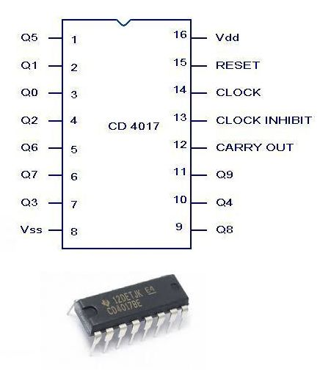

Here is the circuit diagram of 9 V regulator using popular 7809 IC. The 7809 is a 9 Volt voltage regulator IC with features such as internal current limit, safe area protection, thermal protection etc. A 16 V transformer brings down the 230V mains, 1A bridge rectifier rectifies it and capacitor C1 filters it and 7809 regulates it to produce a steady9V DC  output.

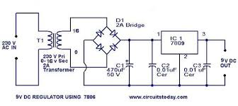

# list of components:

1. ICs
   1. NE555 – 1, Rs 8/-
   2. CD4017 – 1, Rs 20/-
   3. LM7809 – 1 Rs 10/-
2. Resistors
   1. 1 kΩ - 1, Rs 1/-
   2. 47 kΩ (or Variable) – 1, Rs 1/-
   3. 470 Ω - 1, Rs 1/-
3. Capacitors
   1. 1 µF – 1, Rs 10/-
   2. 1000 µF – 1, Rs 10/-
4. Diodes
   1. 1N4007 – 4, Rs 4/-
5. LEDs – 10, Rs 10/-
6. Breadboard & jumper wires – 1, Rs 200/-
7. PCB – 1, Rs 10/-

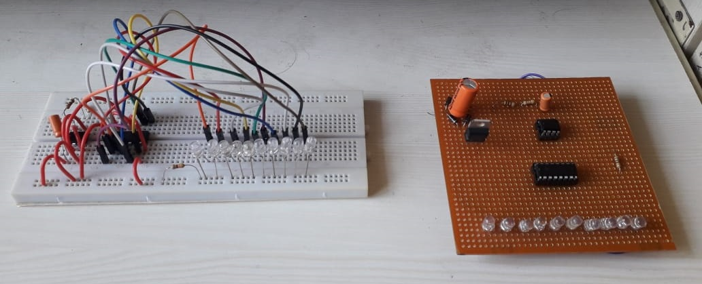

# simulation:

Simulation circuit:

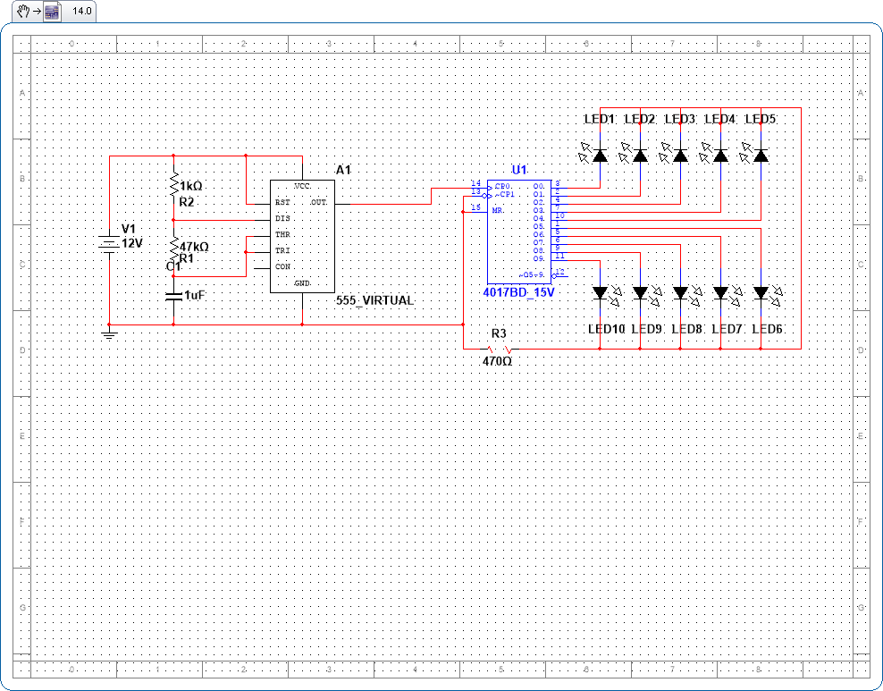

# result:

LED Chaser circuit is working in accordance to the circuit design and LEDs are glowing in sequential manner.